IMT Worksheet 1

All your answers should be in a word document saved in a Git repository under your username. Submit your answers by sending a link to your git repository as a reply to your email.

Define the following concepts using screenshots and text:

* Repository
* A repository is the most basic element of GitHub. They're easiest to imagine as a project's folder. A repository contains all of the project files (including documentation), and stores each file's revision history. Repositories can have multiple collaborators and can be either public or private.

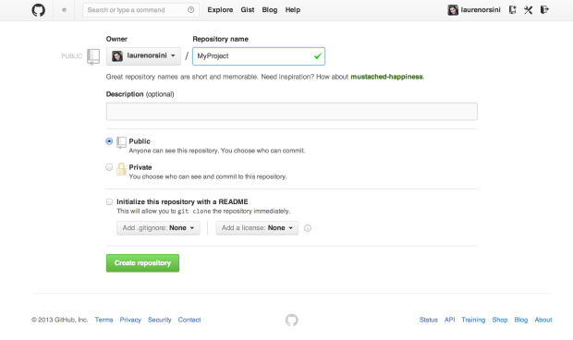

* Commit
* A commit, or "revision", is an individual change to a file (or set of files). It's like when you save a file, except with Git, every time you save it creates a unique ID (a.k.a. the "SHA" or "hash") that allows you to keep record of what changes were made when and by who. Commits usually contain a commit message which is a brief description of what changes were made.

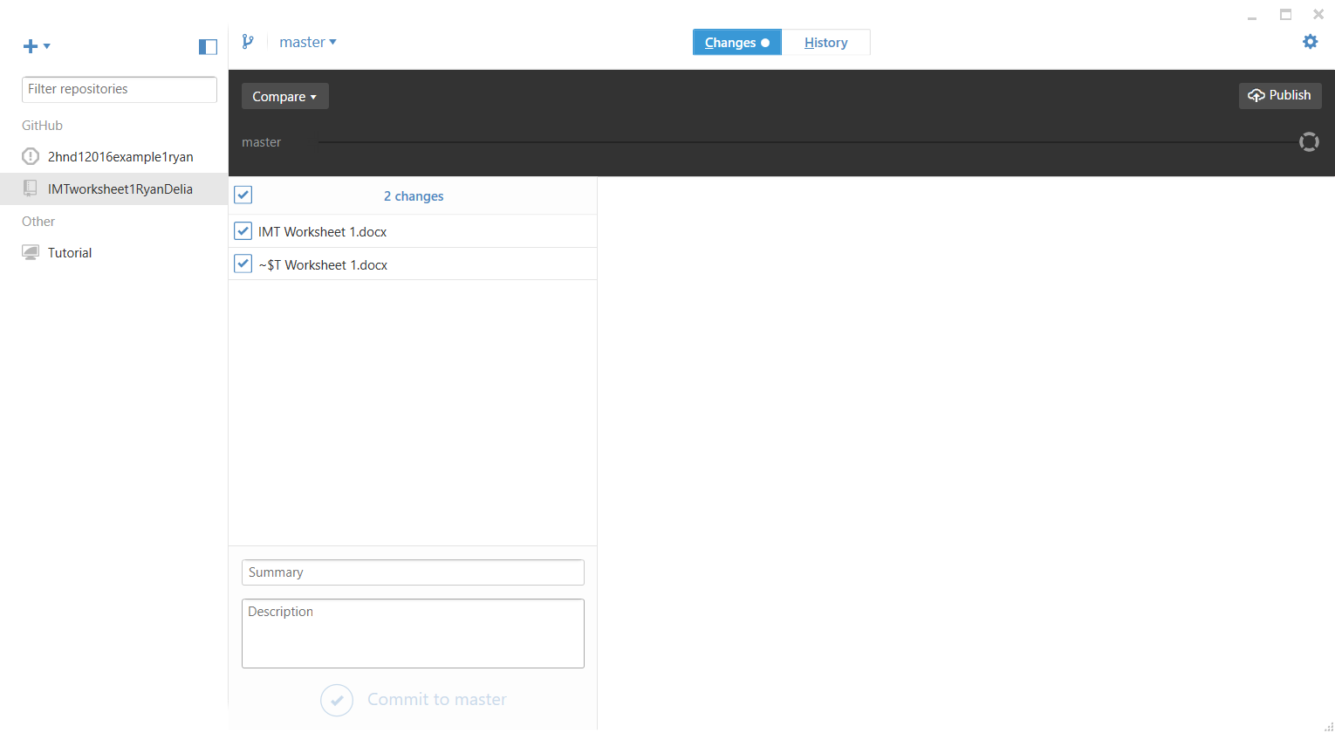

* Commit description
* Its is the description of what is happening in the commit.



* Github desktop
* GitHub Desktop is a seamless way to contribute to projects on GitHub and GitHub Enterprise.

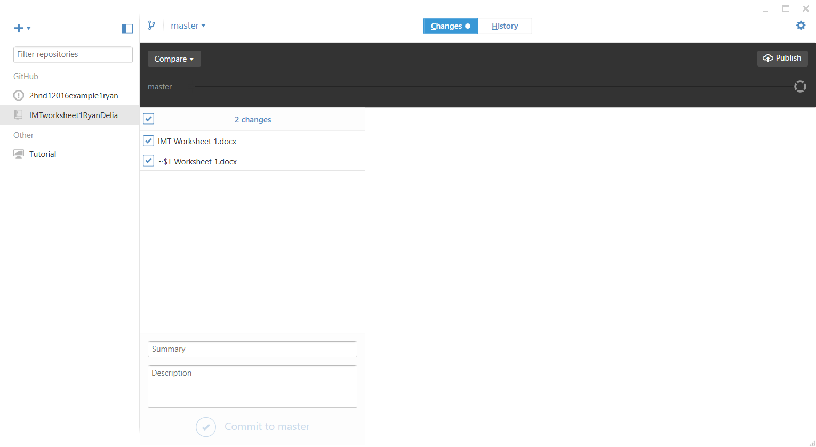

* Git Sync
* As commits are pushed to your project on GitHub, you can keep your local copy of the project in sync with the remote repository.You must sync your local branch with the remote repository to get any additional commits that have been added to the upstream branch since you originally created your branch.

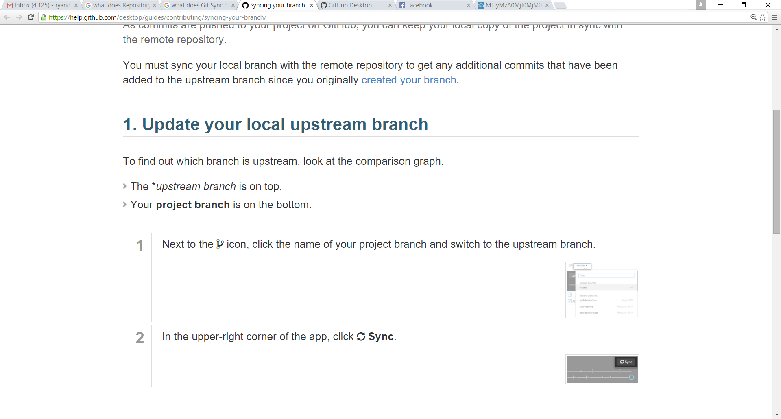

* What ‘download zip’ does.

The download zip is where your files are compresed and than can be download your current work that is saved in the github.

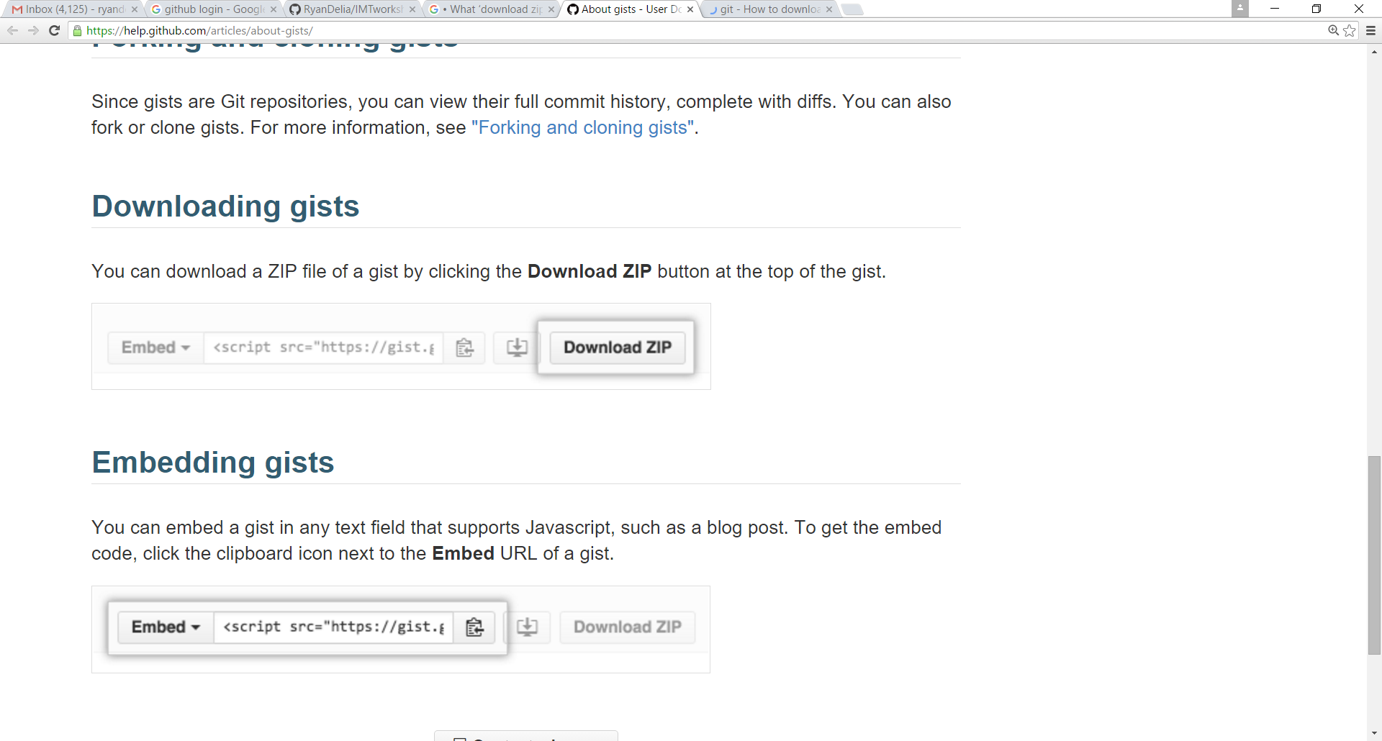

Create a word document and sync it to your Git repository.